**WORKSHEET-3.1**

Student Name: Rahul Maurya UID: 20BCS7260 Branch: CSE Section/Group:PH716/B Semester: 4th

Subject Name: Computer Networks Lab Subject Code: 20CSP-257

**AIM:** Create a network that implement the FTP server.

**REQUIREMENTS:** Cisco packet tracer

**Objective:** Understand Routing Mechanism - Sharing of resources with two connected nodes. Understanding FTP Configure a network using Link State Routing Protocol using Packet Tracer or NS2.

**Steps:**

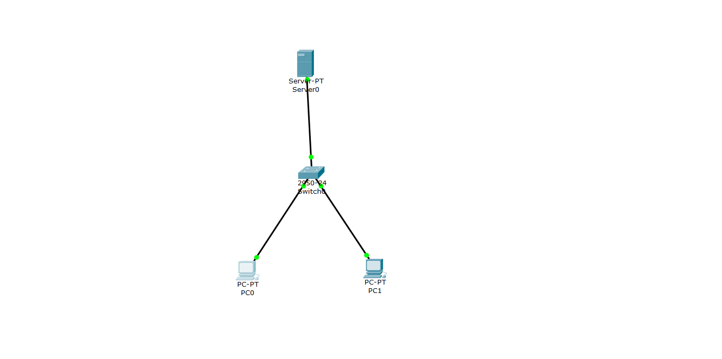

**Switch off all the services except FTP**

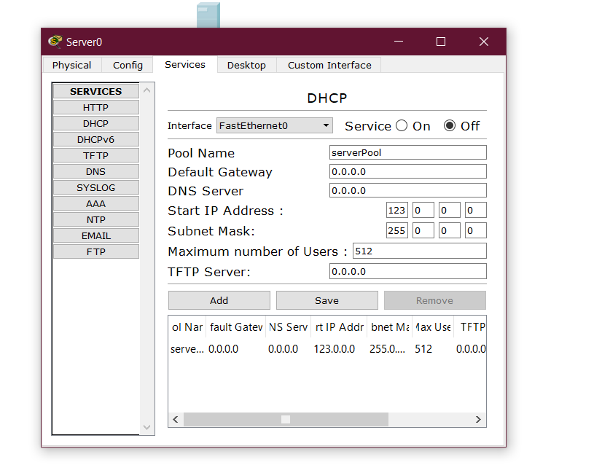

Now in PC 0 Save a file in text editor

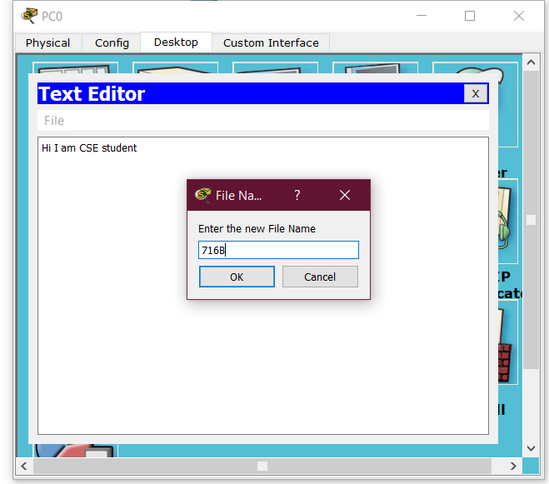

Then in PC 0 open command prompt

Type commands

* ftp
* dir
* put
* dir

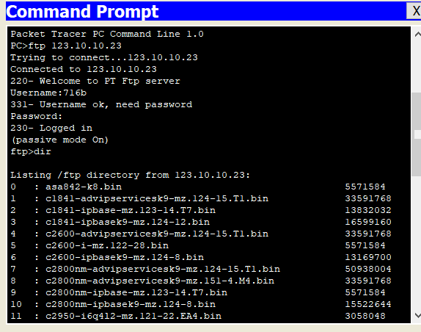

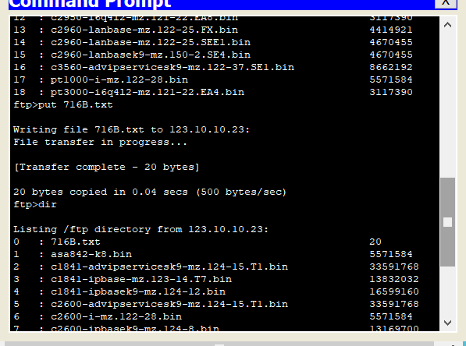

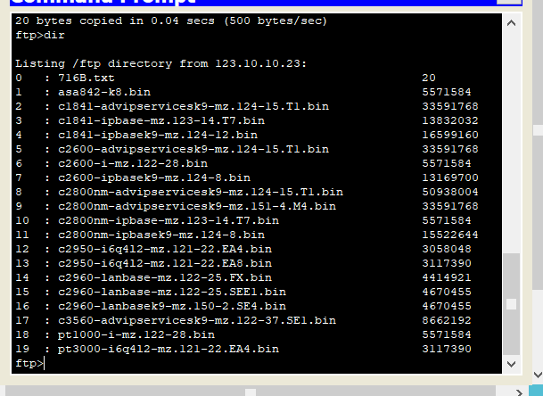

Then in PC 1 open command prompt

Type commands

* ftp
* dir
* get
* dir
* delete
* quit

